《无人机数据接入接口说明》

目 录
目录
目 录 0
1. 接口设计 1
1.1. 接口设计流程说明 1
1.2. 接口接入说明 1
1
2.1. 无人机信息接入接口 2
2.1.1. 接口地址 2
2.1.2. 请求参数和返回结果 2
2.1.3. 参数示例 2
2.1.4. 参数说明 3
2.2.1. 接口地址 3
2.2.2. 请求参数和返回结果 3
2.2.3. 参数示例 4
2.2.4. 参数说明 5
2.3.1接口地址 7
2.3.2请求参数和返回结果 7
2.3.3参数示例 8
2.3.4参数说明 8
2.4.1接口地址 9
2.4.2请求参数和返回结果 9
2.4.3参数示例 10
2.4.4参数说明 10
2. 附录 11
附表1 返回结果编码表 11
附表2 作业类型代码表 12
附表3 终端接入厂家白名单信息登记表 12
信息登记之后发送至邮箱： 12
精准作业平台负责开通终端白名单，开通后返回以下指标 12
接口登录账号：91130101681******* 12
接口登录密码：******** 12
厂家ID: 9788101********1 13

接口设计

接口设计流程说明
首先需要经过用户中心鉴权是否通过，鉴权失败则返回失败信息，鉴权通过则开始数据传输，传输完成则返回成功信息，否则返回失败信息。

接口接入说明

- 精准作业平台为第三方接入厂家分配账号和密码，在向平台接入数据时需要校验账号、密码、IP、厂家ID号码四个属性值，通过才可以备份数据。
验证属性 | 属性说明
account | 账号：精准作业平台分配
password | 密码：精准作业平台分配
factoryId | 厂家ID：白名单开通后，由作业平台分配
infoGuid | UUID : 接入方接入GUID,由作业平台分配

2接口设计

无人机信息接入接口

接口地址
URL: http://47.92.172.74:8084/gpcsConnect_UAV/action/connect?handler=receiveUavInfo

请求参数和返回结果
请求参数：
名称 | 是否必填 | 类型 | 说明
json | true | String | 同步参数及信息
返回结果：
名称 | 是否必填 | 类型 | 说明
NStatus |  |  | 状态码
NDesc |  |  | 是否成功
Result |  |  | 返回结果

参数示例

请求参数示例：
{
"account": "JFHK4419",
"password": "k3ht1h",
"factoryId": "JFHK_JW_20180705171511601",
"infoGuid": "cc50eaafc86447c8aa7666f0290c7630",
"data": [
{
"uav_name": "a12345",
"uav_fuselage_code": "243523",
"uav_flight_num": "234234",
"uav_province": "黑龙江省",
"uav_city": "哈尔滨市",
"uav_district": "阿城区",
"uav_coop": "利新合作社",
"id_card":"2323232",
"owner_name":"方法",
"owner_phone":"456456412313"
},{
"uav_name": "a12345",
"uav_fuselage_code": "243523",
"uav_flight_num": "234234",
"uav_province": "黑龙江省",
"uav_city": "哈尔滨市",
"uav_district": "阿城区",
"uav_coop": "利新合作社",
"id_card":"84965156156151615",
"owner_name":"三十东方",
"owner_phone":"12345678944"
}
]
}支持一次添加多架无人机
返回结果示例：
{"NStatus":0,"NDesc":"success","Result": ""}
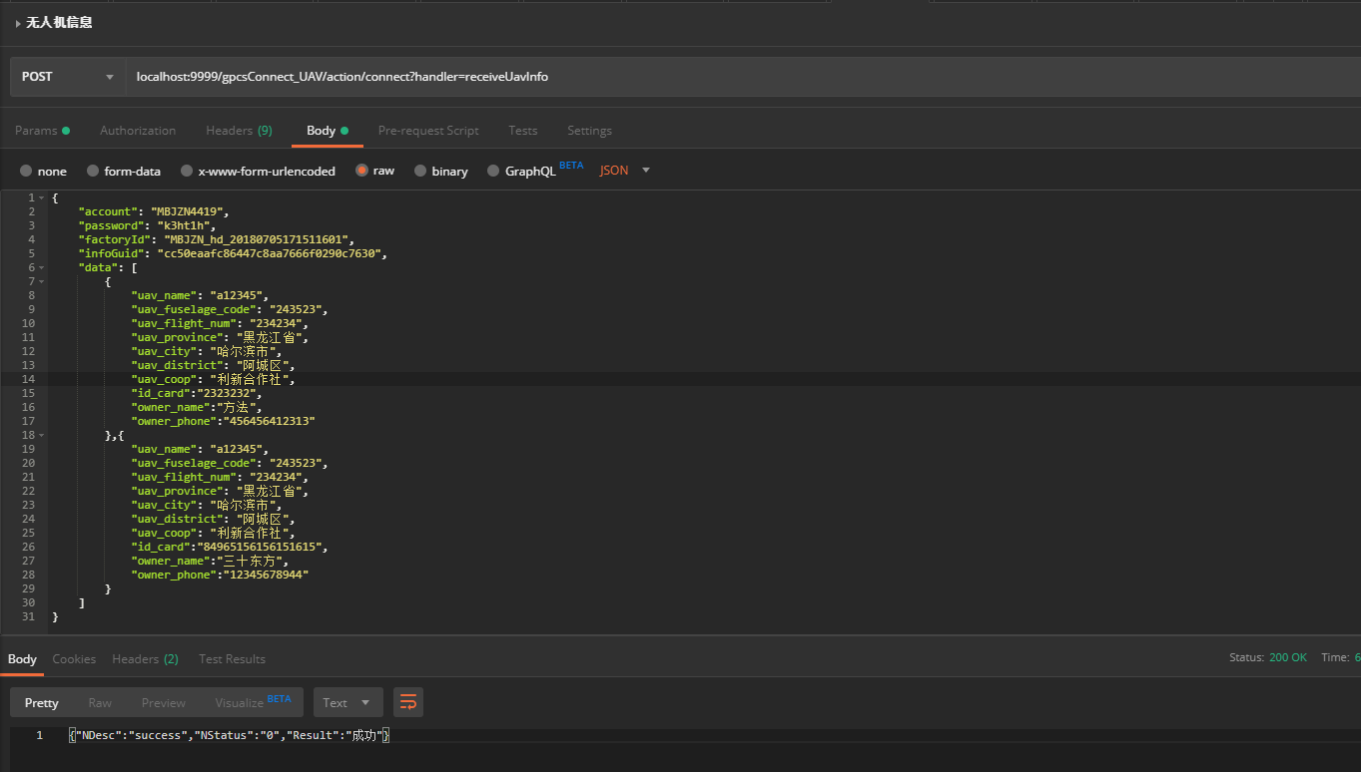

参数说明
终端信息推接口仅支持单条数据传输。
序号 | 名称 | 是否必填 | 类型 | 说明
 | account | true | String | 接入方授权账号
 | password | true | String | 接入方授权密码
 | factoryId | true | String | 厂家ID
 | deviceId | true | String | 终端设备号
 | infoGuid | true | String | 接入方接入GUID
 | uav_name | true | String | 无人机名称
 | uav_fuselage_code | true | String | 机身码
 | uav_flight_num | true | String | 飞控编号
 | uav_province | true | String | 隶属单位 省
 | uav_city | true | String | 隶属单位 市
 | uav_district | true | String | 隶属单位 区县
 | uav_coop | true | String | 隶属单位合作社
 | id_card | true | String | 身份证
 | owner_name | true | String | 机主名
 | owner_phone | true | String | 机主电话
注：上述数据均为必填项。 每天定时推送一次数据

2.2 作业信息接入接口

接口地址
URL: http://47.92.172.74:8084/gpcsConnect_UAV/action/connect?handler?handler=receiveWorkInfo

请求参数和返回结果
请求参数：
名称 | 是否必填 | 类型 | 说明
json | true | String | 同步参数及信息
返回结果：
名称 | 是否必填 | 类型 | 说明
NStatus |  |  | 状态码
NDesc |  |  | 是否成功
Result |  |  | 返回结果

参数示例
请求参数示例：
{
"account": "JFHK4419",
"password": "k3ht1h",
"factoryId": "JFHK_JW_20180705171511601",
"infoGuid": "cc50eaafc86447c8aa7666f0290c7630",
"data": [
{
"uav_fuselage_code": "a12345",
"area": "131",
"area_vaild": "131",
"latitude": "47.65864",
"longitude": "126.4512312",
"operation_time": "542",
"diswork": "100",
"distance": "145",
"speed": "30",
"height": "800",
"spray": "50",
"modes": "自驾模式",
"status": "1",
"work_date": "2019-12-19",
"begin_time": "2019-12-19 10:20:51",
"loc1": "黑龙江省",
"loc2": "哈尔滨市",
"loc3": "双城市",
"loc4": "大王乡东南500米",
"end_time": "2019-12-19 13:50:48",
"workType": "1"
},{
"uav_fuselage_code": "a19846",
"area": "131",
"area_vaild": "131",
"latitude": "47.65864",
"longitude": "126.4512312",
"operation_time": "542",
"diswork": "100",
"distance": "145",
"speed": "30",
"height": "800",
"spray": "50",
"modes": "自驾模式",
"status": "1",
"work_date": "2019-12-19",
"begin_time": "2019-12-19 10:20:51",
"loc1": "黑龙江省",
"loc2": "哈尔滨市",
"loc3": "双城市",
"loc4": "大王乡东南500米",
"end_time": "2019-12-19 13:50:48",
"workType": "1"
}
]
}
返回结果示例：
{"NStatus":0,"NDesc":"success","Result": ""}
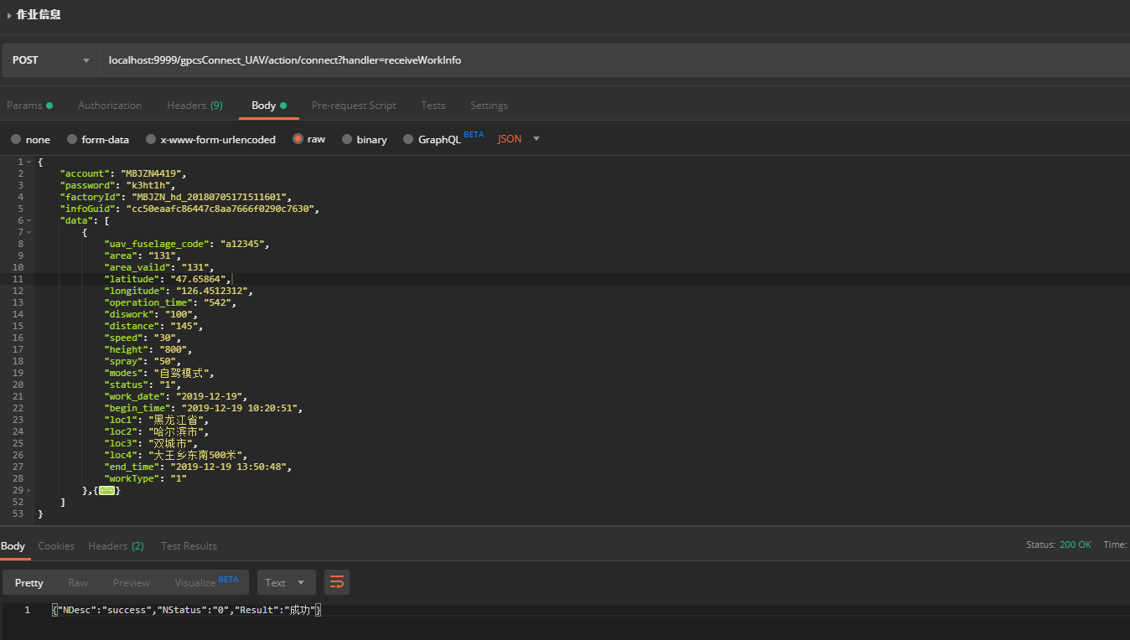

参数说明
作业信息接入接口支持批量接入，按照json数组格式进行接入即可。

序号 | 名称 | 是否必填 | 类型 | 说明
 | account | true | String | 接入方授权账号
 | password | true | String | 接入方授权密码
 | factoryId | true | String | 厂家ID
 | uav_fuselage_code | true | String | 机身码
 | area | true | String | 合格面积
 | area_vaild | true | String | 作业面积
 | work_date | true | String | 作业日期（YYYY-MM-DD）
 | begin_time | true | String | 开始时间（YYYY-MM-DD HH24:MI:SS）
 | end_time | true | String | 结束时间（YYYY-MM-DD HH24:MI:SS）
 | distance | true | String | 行驶里程
 | diswork | true | String | 作业里程
 | longitude | true | String | 作业地点经度
 | latitude | true | String | 作业地点纬度
 | operation_time | true | String | 作业时长 单位分钟
 | height | true | String | 地面高度，单位:米(相对地面高度),精确度:小数点后2位
 | spray | true | String | 喷幅，单位:米,精确度:小数点后2位
 | modes | true | String | 飞行模式：自驾模式、AB作业 等
 | status | true | String | 飞机状态（1开始2结束）
 | work_type | true | String | 见附表2
 | depth | true | String | 耕深（厘米<cm>）
 | speed | true | String | 平均速度 千米/时
 | loc1 | true | String | 作业地点-省
 | loc2 | true | String | 作业地点-市
 | loc3 | true | String | 作业地点-区县
 | loc4 | true | String | 作业地点-具体位置 xxx乡/村东南xxx米

注：是否必填列为true的为必须传输属性，如没有须填写“0”
注：上述数据均为必填项。 每天定时推送一次数据

2.3 无人机最新实时定位信息接入接口

2.3.1接口地址
URL: http://47.92.172.74:8084/gpcsConnect_UAV/action/connect?handler?handler=receiveUavRT

2.3.2请求参数和返回结果
请求参数：
名称 | 是否必填 | 类型 | 说明
json | true | String | 同步参数及信息
返回结果：
名称 | 是否必填 | 类型 | 说明
NStatus |  |  | 状态码
NDesc |  |  | 是否成功
Result |  |  | 返回结果

2.3.3参数示例
请求参数示例：
{
"account": "JFHK4419",
"password": "k3ht1h",
"factoryId": "JFHK_JW_20180705171511601",
"infoGuid": "cc50eaafc86447c8aa7666f0290c7630",
"data": [
{
"uav_fuselage_code": "a12389",
"gps_time": "2019-12-19 10:20:51",
"latitude": "47.65482",
"longitude": "126.84562",
"speed": "30",
"height": "30",
"course":"56"
},{
"uav_fuselage_code": "a12456",
"gps_time": "2019-12-19 10:20:51",
"latitude": "47.65482",
"longitude": "126.84562",
"speed": "30",
"height": "30",
"course":"152"
}
]
}
返回结果示例：
{"NStatus":0,"NDesc":"success","Result": ""}
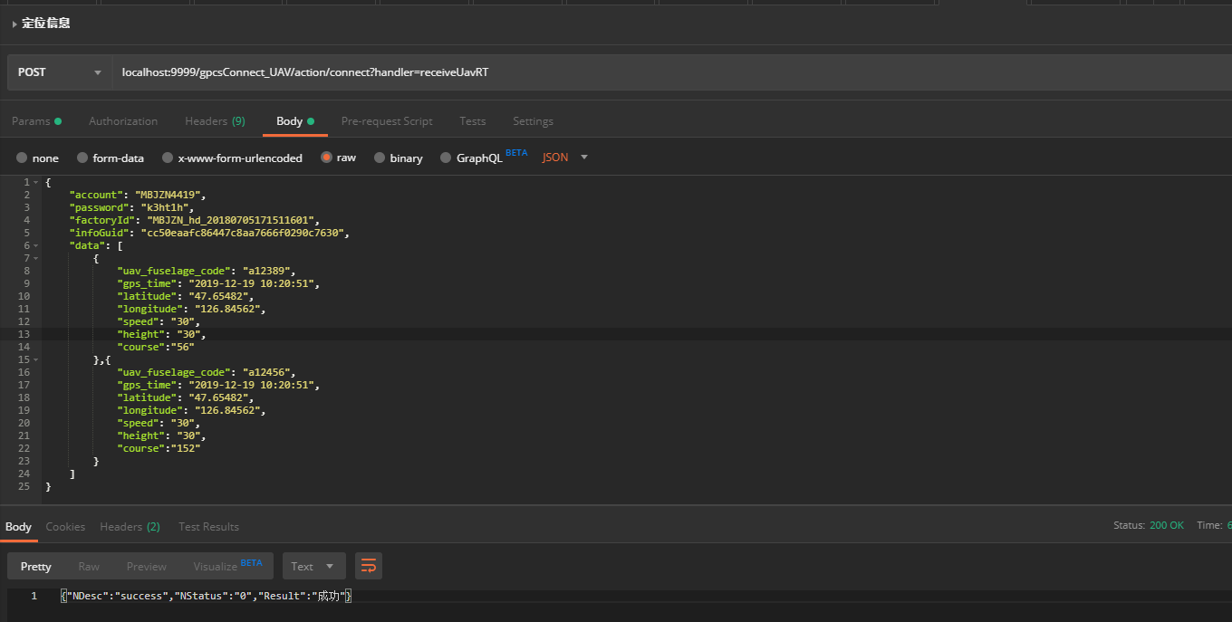

2.3.4参数说明
接口支持批量接入，按照json数组格式进行接入即可。

序号 | 名称 | 是否必填 | 类型 | 说明
1. | account | true | String | 接入方授权账号
2. | password | true | String | 接入方授权密码
3. | factoryId | true | String | 厂家ID
4. | uav_fuselage_code | true | String | 机身码
5. | gps_time | true | String | 定位时间（YYYY-MM-DD HH24:MI:SS）
6. | longitude | true | String | 作业地点经度
7. | latitude | true | String | 作业地点纬度
8. | speed | true | String | 速度
9. | height | true | String | 地面高度，单位:米(相对地面高度),精确度:小数点后2位
10. | course | true | String | 航向角

注：是否必填列为true的为必须传输属性，如没有须填写“0”
此接口需要每5分钟同步一次最新定位信息

2.4 无人机作业轨迹信息接入接口

2.4.1接口地址
URL: http://47.92.172.74:8084/gpcsConnect_UAV/action/connect?handler?handler=receiveUavTrace

2.4.2请求参数和返回结果
请求参数：
名称 | 是否必填 | 类型 | 说明
json | true | String | 同步参数及信息
返回结果：
名称 | 是否必填 | 类型 | 说明
NStatus |  |  | 状态码
NDesc |  |  | 是否成功
Result |  |  | 返回结果

2.4.3参数示例
请求参数示例：
{
"account": "JFHK4419",
"password": "k3ht1h",
"factoryId": "JFHK_JW_20180705171511601",
"infoGuid": "cc50eaafc86447c8aa7666f0290c7630",
"data": [
{
"uav_fuselage_code": "a12345",
"gps_time": "2019-12-19 10:20:51",
"latitude": "47.65482",
"longitude": "126.84562",
"speed": "310",
"work_flag": "1",
"course": "256",
"height": "30"
},{
"uav_fuselage_code": "a12356",
"gps_time": "2019-12-19 10:20:51",
"latitude": "47.65482",
"longitude": "126.84562",
"speed": "302",
"work_flag": "1",
"course": "256",
"height": "30"
}
]
}
返回结果示例：
{"NStatus":0,"NDesc":"success","Result": ""}
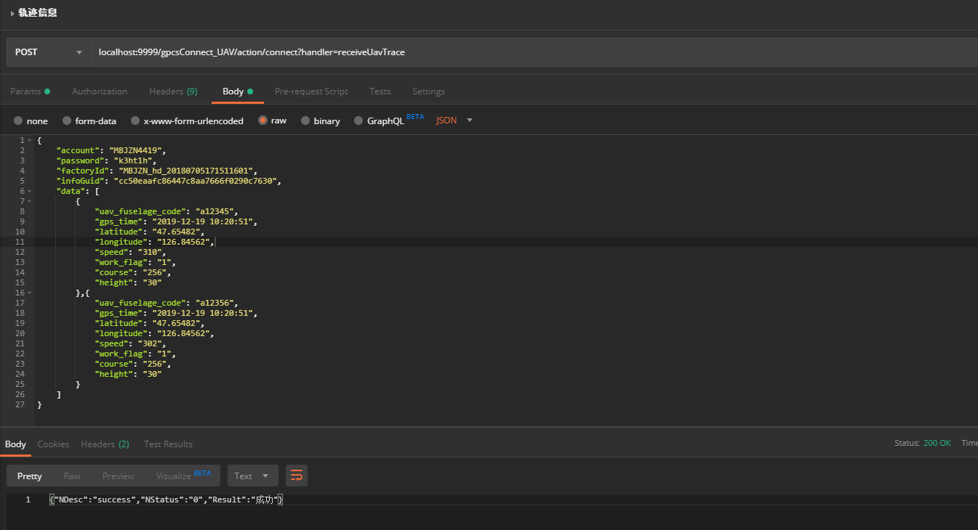

2.4.4参数说明
接口支持批量接入，按照json数组格式进行接入即可。

序号 | 名称 | 是否必填 | 类型 | 说明
1. | account | true | String | 接入方授权账号
2. | password | true | String | 接入方授权密码
3. | factoryId | true | String | 厂家ID
4. | uav_fuselage_code | true | String | 机身码
5. | gps_time | true | String | 定位时间（YYYY-MM-DD HH24:MI:SS）
6. | longitude | true | String | 作业地点经度
7. | latitude | true | String | 作业地点纬度
8. | speed | true | String | 速度
9. | height | true | String | 地面高度，单位:米(相对地面高度),精确度:小数点后2位
10. | course | true | String | 航向角
11. | work_flag | true | String | 作业状态 1作业 0非作业

注：是否必填列为true的为必须传输属性，如没有须填写“0”
注：上述数据均为必填项。 每天定时推送一次数据

注：上述所有的经纬度坐标，坐标系统一为wgs84坐标系

附录

附表1 返回结果编码表
接入结果状态码 | 接入结果状态说明
0 | 成功
100 | 账号密码错误
101 | IP地址不符
102 | 厂家ID不存在
200 | 必填信息不完整
201 | 数据格式错误
300 | JSON协议错误
404 | 请求URL错误
500 | 接口内部错误（请联系技术支撑）
600 | 接口服务繁忙，稍后重试
999 | 未知错误（请联系技术支撑）

附表2 作业类型代码表
·作业类型 | 作业类型说明
1 | 播种作业
2 | 植保作业
3 | 撒肥作业
4 | 作物授粉作业
5 | 其他作业

附表3 终端接入厂家白名单信息登记表
工商注册号码 |  | 终端厂家名称
终端品牌 |  | 终端型号
联系人 |  | 联系电话
绑定IP
接口对接人qq号码或微信号码

信息登记之后发送至邮箱：

精准作业平台负责开通终端白名单，开通后返回以下指标

接口登录账号：91130101681*******

接口登录密码：********

厂家ID: 9788101********1

技术联系人：毕明亮 18746042175

